The Order for Morning Prayer for
The 16th Sunday after Trinity
September 27, 2020

Morning Prayer

Prayers for the week of Trinity XVI
Pray for our country, the president, all representatives, the military, and those in public service. Pray for our state, the governor, all representatives, and all who serve the state.
Pray for the city of Prescott.
Pray for the Anglican Province of American, and our bishops.
Pray for St. Dunstan’s Church and Fr. John Longcamp.
Pray for The Indigenous Pastoral of the Anglican Province in Ecuador.
Pray for Shepherd of the Hills Lutheran, Solid Rock, and all local churches, that they would fervently preach the gospel
Pray for All Saints, all our members, and for wisdom and guidance in learning to love our neighbors as ourselves.
Pray for The Vestry
Pray for:
Don Feher and his illness.
Cathy Foster - rash
Earle – cancer treatment
Jim – in hospital
Marriann – pain and headaches
Robby – continued recover from his surgery
Holly – continued recover from her surgery
Ann – loss of multiple family members

To submit prayer requests please email Fr. Ian prior to Thursday at rector@allsaintsprescott.org

Visiting for the first time?
Use the camera on your phone to read the QR code to sign our virtual guest book

You may use the same code to access online giving

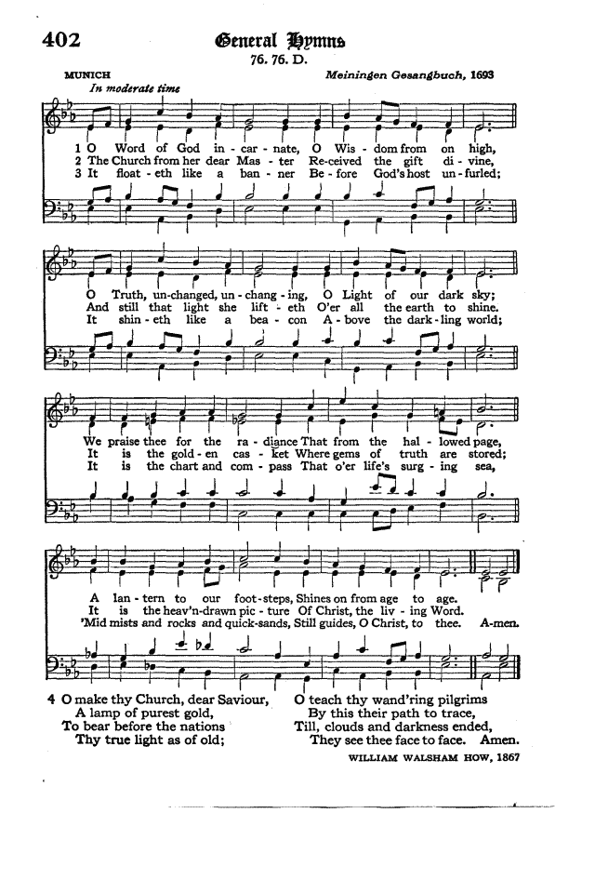
LET us humbly confess our sins unto Almighty God.

A General Confession, to be said by all gathered:

ALMIGHTY and most merciful Father; We have erred, and strayed from thy ways like lost sheep. We have followed too much the devices and desires of our own hearts. We have offended against thy holy laws. We have left undone those things which we ought to have done; And we have done those things which we ought not to have done; And there is no health in us. But thou, O Lord, have mercy upon us, miserable offenders. Spare thou those, O God, who confess their faults. Restore thou those who are penitent; According to thy promises declared unto mankind In Christ Jesus our Lord. And grant, O most merciful Father, for his sake; That we may hereafter live a godly, righteous, and sober life, To the glory of thy holy Name. Amen.

Then the priest shall pray the absolution:
GRANT, we beseech thee, merciful Lord, to thy faithful people pardon and peace, that they may be cleansed from all their sins, and serve thee with a quiet mind; through Jesus Christ our Lord. Amen.

All together:
OUR Father, who art in heaven, Hallowed be thy Name. Thy kingdom come. Thy will be done, On earth as it is in heaven. Give us this day our daily bread. And forgive us our trespasses, As we forgive those who trespass against us. And lead us not into temptation, But deliver us from evil. For thine is the kingdom, and the power, and the glory, for ever and ever. Amen.

Then likewise he shall say,
O Lord, open thou our lips.
Answer. And our mouth shall show forth thy praise.

Here the leader shall say,
Glory be to the Father, and to the Son, and to the Holy Ghost;
Answer. As it was in the beginning, is now, and ever shall be, world without end. Amen.
Leader: Praise ye the Lord.
Answer. The Lord’s Name be praised.

Then shall be said or sung the following Canticle;
Venite, exultemus Domino.

O COME, let us sing unto the LORD; * let us heartily rejoice in the strength of our salvation.
Let us come before his presence with thanksgiving; * and show ourselves glad in him with psalms.
For the LORD is a great God; * and a great King above all gods.
In his hand are all the corners of the earth; * and the strength of the hills is his also.
The sea is his, and he made it; * and his hands prepared the dry land.
O come, let us worship and fall down, * and kneel before the LORD our Maker.
For he is the Lord our God; * and we are the people of his pasture, and the sheep of his hand.
O worship the LORD in the beauty of holiness; * let the whole earth stand in awe of him. For he cometh, for he cometh to judge the earth; * and with righteousness to judge the world, and the peoples with his truth.
GLORY be to the Father, and to the Son, * and to the Holy Ghost; AS it was in the beginning, is now, and ever shall be, * world without end. Amen.

Then shall follow a Portion of the Psalms, followed by the Gloria Patri:

Psalm 116
MY delight is in the LORD; * because he hath heard the voice of my prayer;
Because he hath inclined his ear unto me; * therefore will I call upon him as long as I live.
The snares of death compassed me round about, * and the pains of hell gat hold upon me.
I found trouble and heaviness; then called I upon the Name of the LORD; * O LORD, I beseech thee, deliver my soul.
Gracious is the LORD, and righteous; * yea, our God is merciful.
The LORD preserveth the simple: * I was in misery, and he helped me.
Turn again then unto thy rest, O my soul; * for the LORD hath rewarded thee.
And why? thou hast delivered my soul from death, * mine eyes from tears, and my feet from falling.
I will walk before the LORD * in the land of the living.
I believed, and therefore will I speak; but I was sore troubled: * I said in my haste, All men are liars.
What reward shall I give unto the LORD * for all the benefits that he hath done unto me?
I will receive the cup of salvation, * and call upon the Name of the LORD.
I will pay my vows now in the presence of all his people: * right dear in the sight of the LORD is the death of his saints.
Behold, O LORD, how that I am thy servant; * I am thy servant, and the son of thine handmaid; thou hast broken my bonds in sunder.
I will offer to thee the sacrifice of thanksgiving, * and will call upon the Name of the LORD.
I will pay my vows unto the LORD, in the sight of all his people, * in the courts of the LORD'S house; even in the midst of thee, O Jerusalem. Praise the LORD.

Then Shall be read the First Lesson for Morning Prayer

Isaiah 12
You will say in that day:
“I will give thanks to you, O Lord,
for though you were angry with me,
your anger turned away,
that you might comfort me.
“Behold, God is my salvation;
I will trust, and will not be afraid;
for the Lord God is my strength and my song,
and he has become my salvation.”
With joy you will draw water from the wells of salvation. And you will say in that day:
“Give thanks to the Lord,
call upon his name,
make known his deeds among the peoples,
proclaim that his name is exalted.
“Sing praises to the Lord, for he has done gloriously;
let this be made known in all the earth.
Shout, and sing for joy, O inhabitant of Zion,
for great in your midst is the Holy One of Israel.”

Then shall be read or sung: Benedictus es, Domine.

BLESSED art thou, O Lord God of our fathers:* praised and exalted above all for ever.
Blessed art thou for the Name of thy Majesty:* praised and exalted above all for ever.
Blessed art thou in the temple of thy holiness:* praised and exalted above all for ever.
Blessed art thou that beholdest the depths, and dwellest between the Cherubim: * praised and exalted above all forever.
Blessed art thou on the glorious throne of thy kingdom: * praised and exalted above all for ever. Blessed art thou in the firmament of heaven: * praised and exalted above all for ever.
GLORY be to the Father, and to the Son, * and to the Holy Ghost;
AS it was in the beginning, is now, and ever shall be, * world without end. Amen.

Then shall be read the Second Lesson

Luke 7:11-17iPP
Soon afterward he went to a town called Nain, and his disciples and a great crowd went with him. As he drew near to the gate of the town, behold, a man who had died was being carried out, the only son of his mother, and she was a widow, and a considerable crowd from the town was with her. And when the Lord saw her, he had compassion on her and said to her, “Do not weep.” Then he came up and touched the bier, and the bearers stood still. And he said, “Young man, I say to you, arise.” And the dead man sat up and began to speak, and Jesus gave him to his mother. Fear seized them all, and they glorified God, saying, “A great prophet has arisen among us!” and “God has visited his people!” And this report about him spread through the whole of Judea and all the surrounding country.

Then shall be read or sung: Jubilate Deo. Psalm c.

O BE joyful in the LORD, all ye lands: * serve the LORD with gladness, and come before his presence with a song.
Be ye sure that the LORD he is God; it is he that hath made us, and not we ourselves; * we are his people, and the sheep of his pasture.
O go your way into his gates with thanksgiving, and into his courts with praise; * be thankful unto him, and speak good of his Name.
For the LORD is gracious, his mercy is everlasting; * and his truth endureth from generation to generation.
GLORY be to the Father, and to the Son, * and to the Holy Ghost;
AS it was in the beginning, is now, and ever shall be, * world without end. Amen.

Then shall be said the Apostles’ Creed by all

I BELIEVE in God the Father Almighty, Maker of heaven and earth: And in Jesus Christ his only Son our Lord: Who was conceived by the Holy Ghost, Born of the Virgin Mary: Suffered under Pontius Pilate, Was crucified, dead, and buried: He descended into hell; The third day he rose again from the dead: He ascended into heaven, And sitteth on the right hand of God the Father Almighty: From thence he shall come to judge the quick and the dead. I believe in the Holy Ghost: The holy Catholic Church; The Communion of Saints: The Forgiveness of sins: The Resurrection of the body: And the Life everlasting. Amen. Then the leader says: The Lord be with you. Answer. And with thy spirit. Leader: Let us pray. Leader. O Lord, show thy mercy upon us. Answer. And grant us thy salvation. Leader. O God, make clean our hearts within us. Answer. And take not thy Holy Spirit from us.

Then shall be said the Collects,
Sixteenth Sunday after Trinity
O LORD, we beseech thee, let thy continual pity cleanse and defend thy Church; and, because it cannot continue in safety without thy succour, preserve it evermore by thy help and goodness; through Jesus Christ our Lord. Amen.

A Collect for Peace.
O GOD, who art the author of peace and lover of concord, in knowledge of whom standeth our eternal life, whose service is perfect freedom; Defend us thy humble servants in all assaults of our enemies; that we, surely trusting in thy defence, may not fear the power of any adversaries, through the might of Jesus Christ our Lord. Amen.

A Collect for Grace.
O Lord, our heavenly Father, Almighty and everlasting God, who hast safely brought us to the beginning of this day; Defend us in the same with thy mighty power; and grant that this day we fall into no sin, neither run into any kind of danger; but that all our doings, being ordered by thy governance, may be righteous in thy sight; through Jesus Christ our Lord. Amen.

In Time of Great Sickness and Mortality.
O MOST mighty and merciful God, in this time of grievous sickness, we flee unto thee for succour. Deliver us, we beseech thee, from our peril; give strength and skill to all those who minister to the sick; prosper the means made use of for their cure; and grant that, perceiving how frail and uncertain our life is, we may apply our hearts unto that heavenly wisdom which leadeth to eternal life; through Jesus Christ our Lord. Amen.

Offertory Hymn on next page
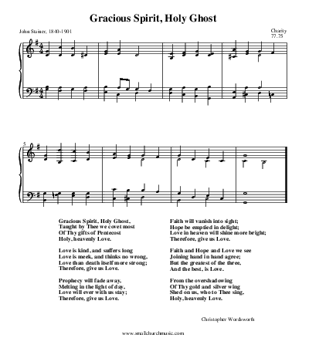

A Prayer for The President of the United States, and all in Civil Authority. O LORD our Governor, whose glory is in all the world; We commend this nation to thy merciful care, that being guided by thy Providence, we may dwell secure in thy peace. Grant to THE PRESIDENT OF THE UNITED STATES, and to all in authority, wisdom and strength to know and to do thy will. Fill them with the love of truth and righteousness; and make them ever mindful of their calling to serve this people in thy fear; through Jesus Christ our Lord, who liveth and reigneth with thee and the Holy Ghost, one God, world without end. Amen.

A Prayer for the Clergy and People.
Almighty and everlasting God, from whom cometh every good and perfect gift; Send down upon our Bishops, especially +Walter and +Robert, and other Clergy, and upon the Congregations committed to their charge, the healthful Spirit of thy grace; and, that they may truly please thee, pour upon them the continual dew of thy blessing. Grant this, O Lord, for the honour of our Advocate and Mediator, Jesus Christ. Amen.

A Prayer for All Conditions of Men.
O God, the Creator and Preserver of all mankind, we humbly beseech thee for all sorts and conditions of men; that thou wouldest be pleased to make thy ways known unto them, thy saving health unto all nations. More especially we pray for thy holy Church universal; that it may be so guided and governed by thy good Spirit, that all who profess and call themselves Christians may be led into the way of truth, and hold the faith in unity of spirit, in the bond of peace, and in righteousness of life. Finally, we commend to thy fatherly goodness all those who are any ways afflicted, or distressed, in mind, body, or estate; that it may please thee to comfort and relieve them, according to their several necessities; giving them patience under their sufferings, and a happy issue out of all their afflictions. And this we beg for Jesus Christ’s sake. Amen.

A General Thanksgiving. – prayed together
Almighty God, Father of all mercies, we, thine unworthy servants, do give thee most humble and hearty thanks for all thy goodness and lovingkindness to us, and to all men; We bless thee for our creation, preservation, and all the blessings of this life; but above all, for thine inestimable love in the redemption of the world by our Lord Jesus Christ; for the means of grace, and for the hope of glory. And, we beseech thee, give us that due sense of all thy mercies that our hearts may be unfeignedly thankful; and that we show forth thy praise, not only with our lips, but in our lives, by giving up our selves to thy service, and by walking before thee in holiness and righteousness all our days; through Jesus Christ our Lord, to whom, with thee and the Holy Ghost, be all honour and glory, world without end. Amen.

A Prayer of St. Chrysostom
Almighty God, who hast given us grace at this time with one accord to make our common supplications unto thee; and dost promise that when two or three are gathered together in thy Name thou wilt grant their requests; Fulfil now, O Lord, the desires and petitions of thy servants, as may be most expedient for them; granting us in this world knowledge of thy truth, and in the world to come life everlasting. Amen.

2 Cor. xiii. 14.
The grace of our Lord Jesus Christ, and the love of God, and the fellowship of the Holy Ghost, be with us all evermore. Amen.

